Home page for the web application when you will be guided in the beginning

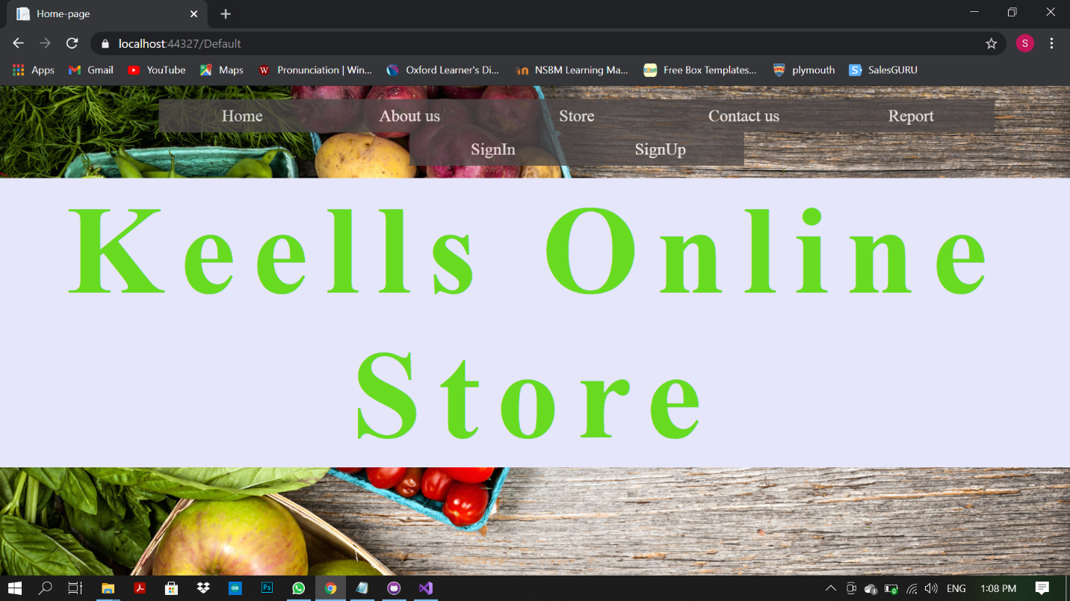

After Clicking SignIn Button you will redirect to Farmer’s sign in page

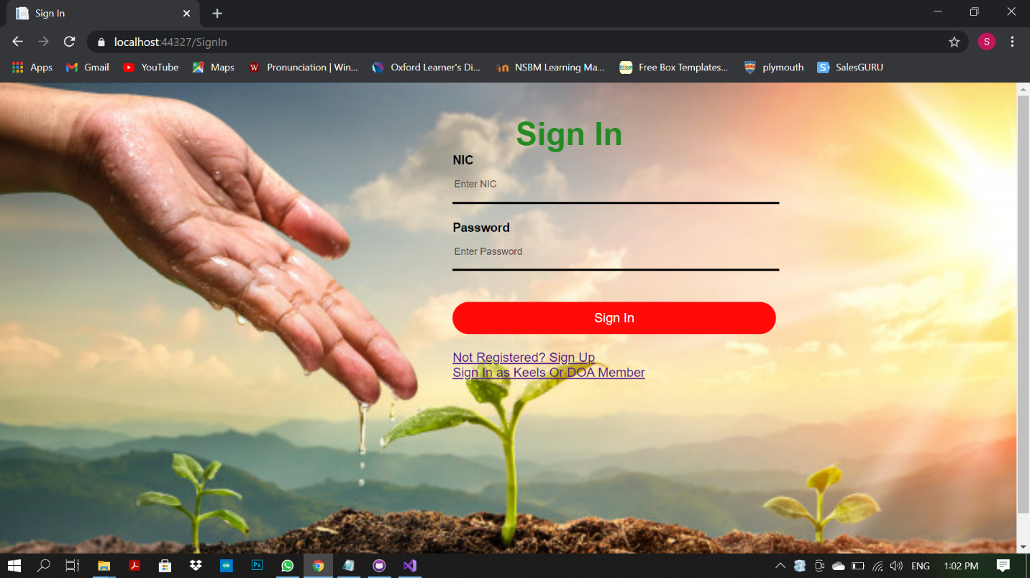

Farmers can Sign in using NIC and Password to account created by them.

There is link to Sign in as Keels or DoA Staff member 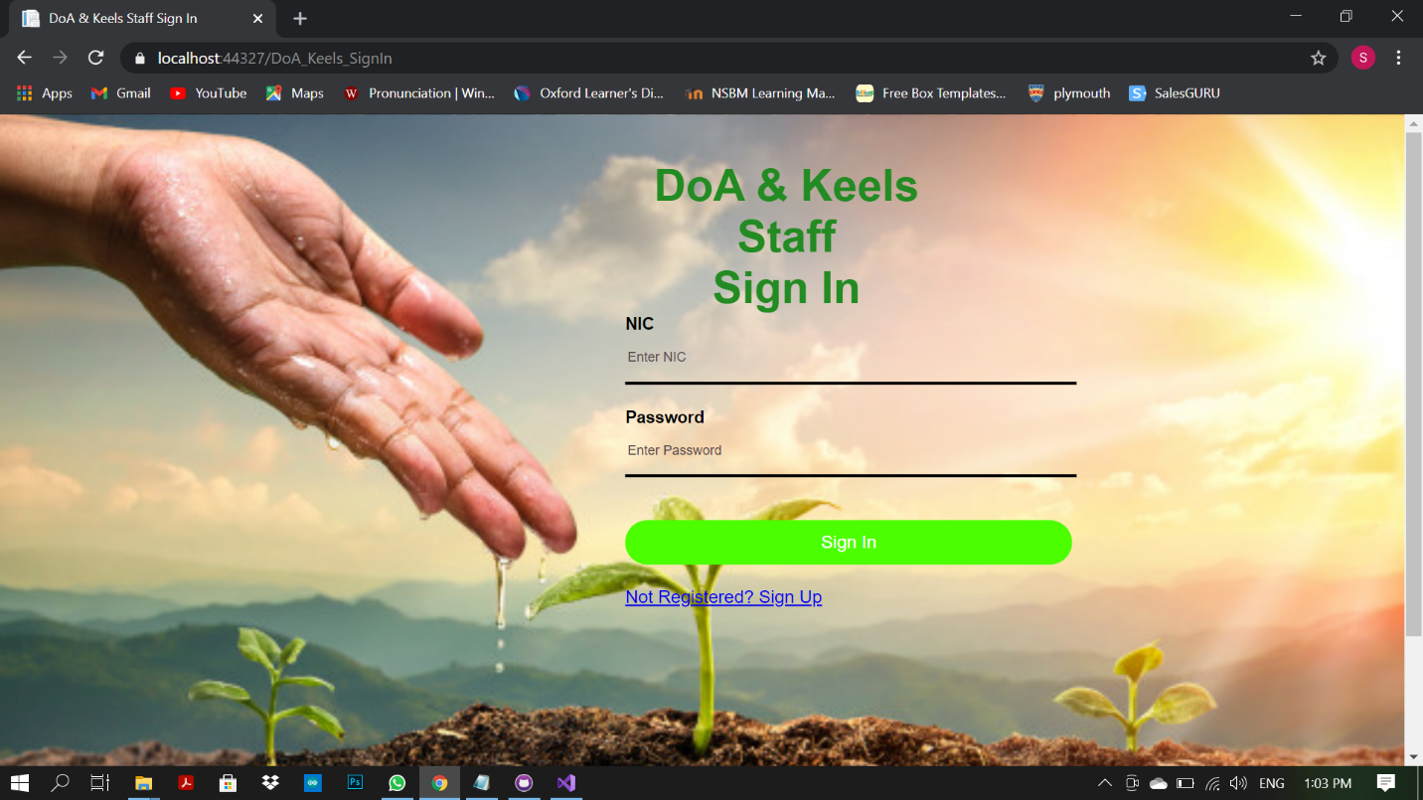

Also staff members can Sign in using NIC and Password to account

In both images above has 2 links shown as “Not Registered? Sign Up”

You can create Both accounts (farmer and staff) from this links Or SignUp Button located in Home page(first Image)

If you create account as farmer you van create account after filling required fields as below,

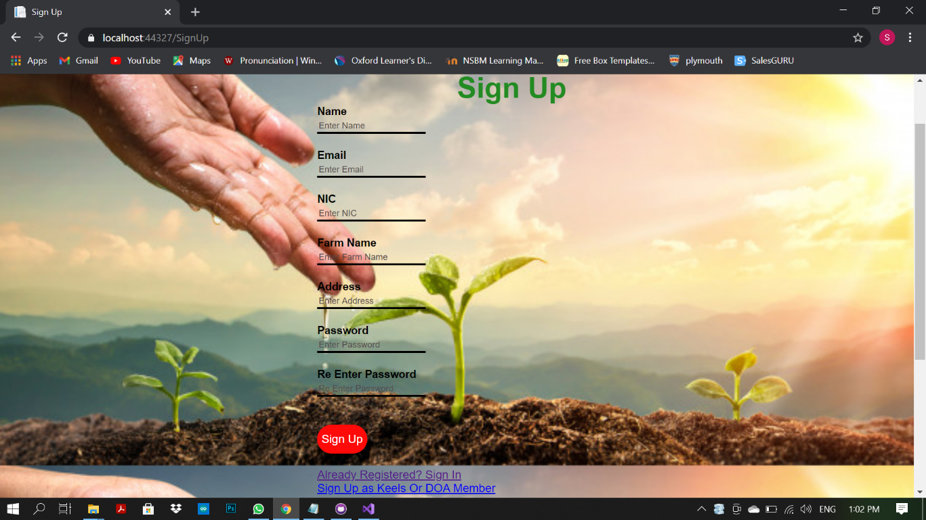

If you create account as Staff member First you have to authenticate Web Admin Via web admin password in below form

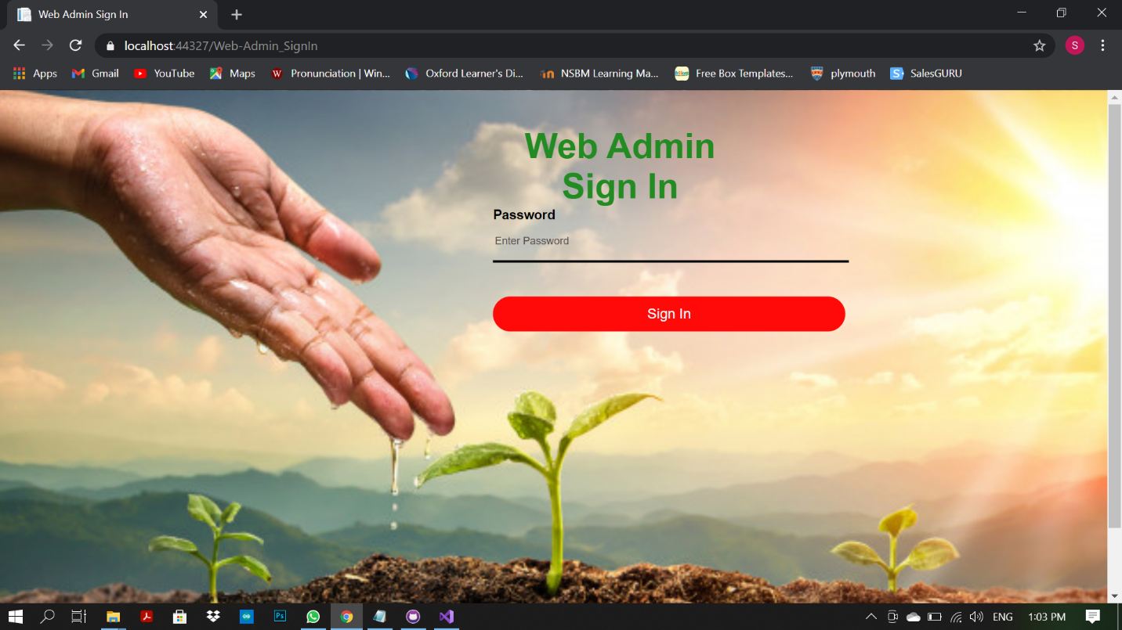

If you Correctly entered web admin password You can proceed to create staff account

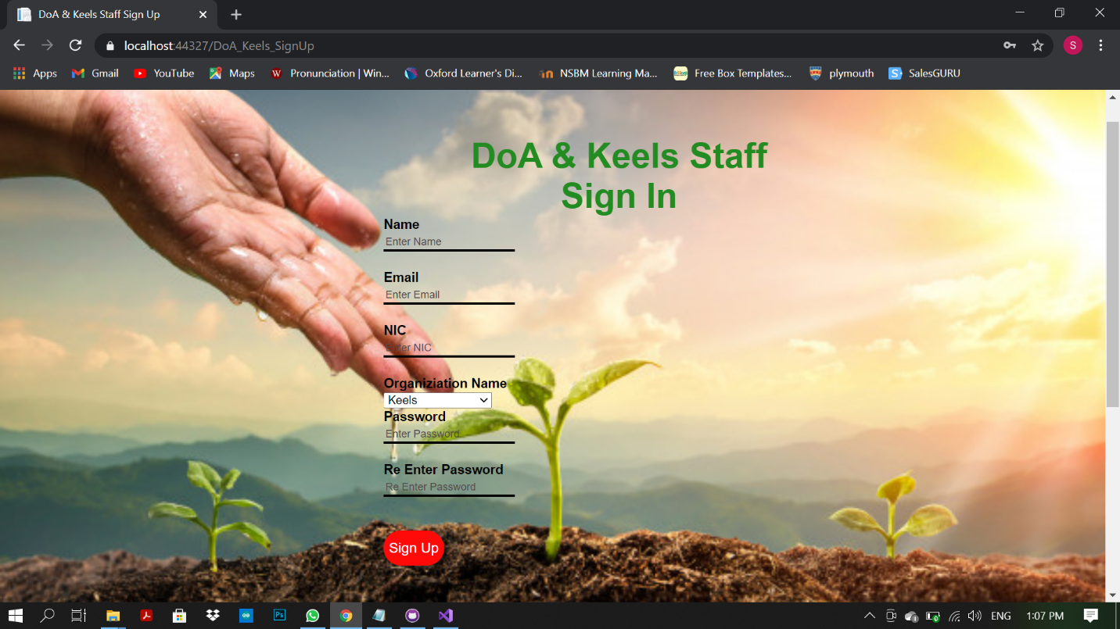

After You logged as farmer you will redirect to farmers’ portal as below,

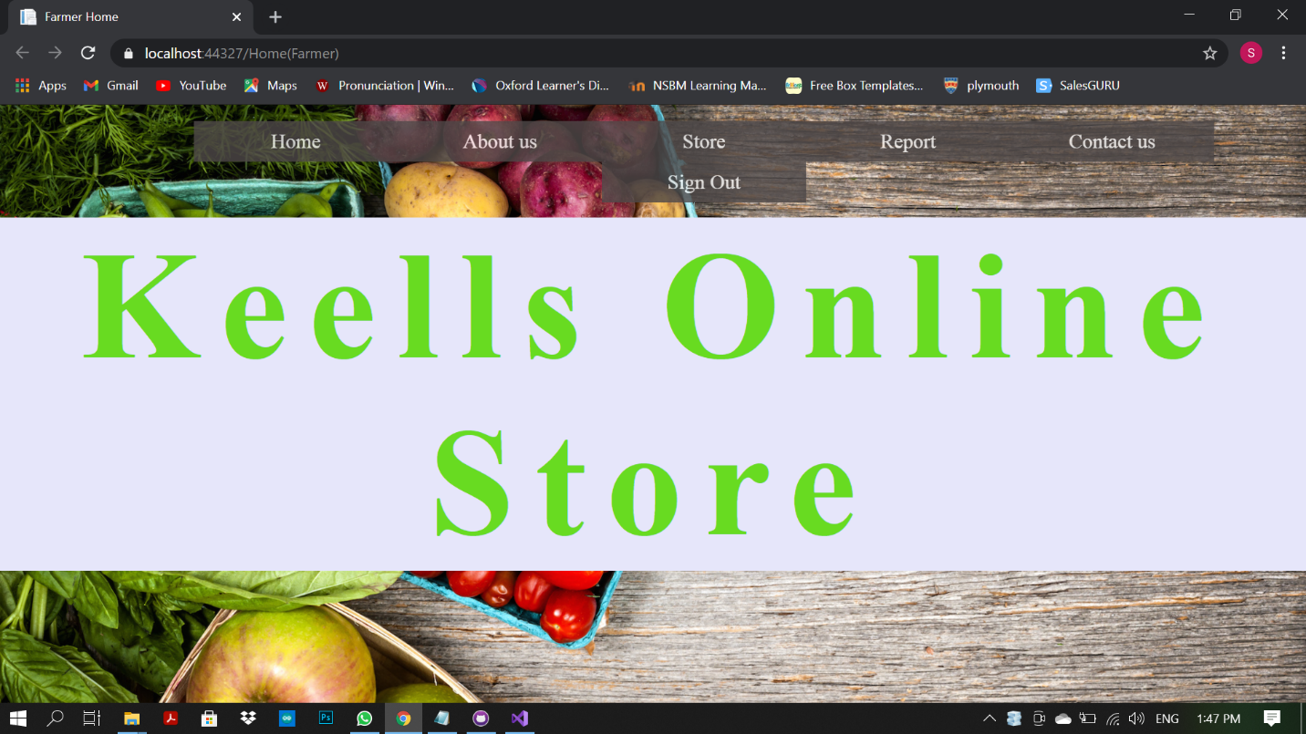

If You logged as Staff member you will redirect to Staff portal as below,

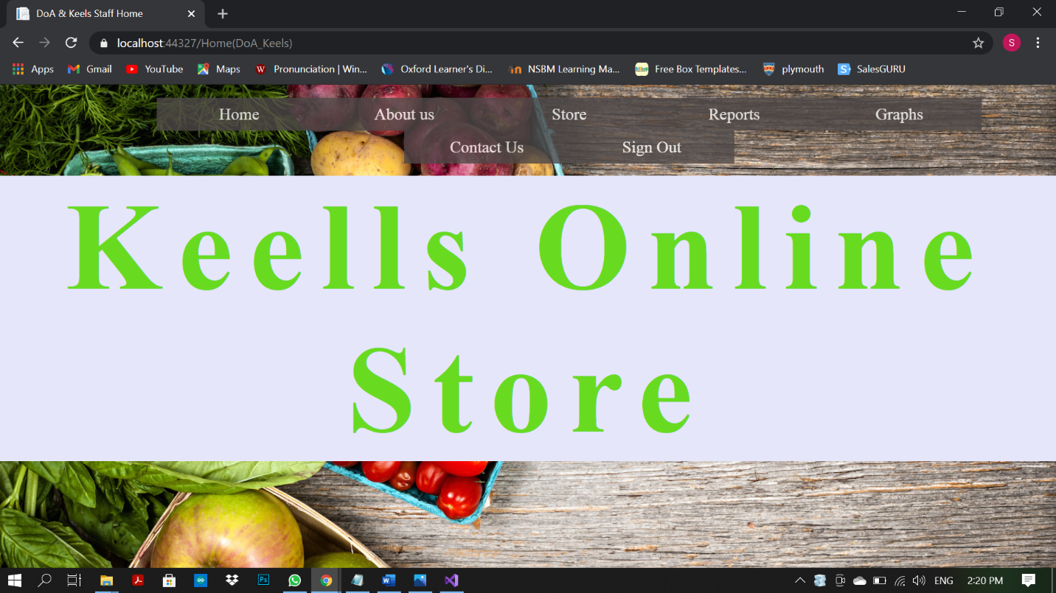

You can simply sign Out using Sign Out Button , After clicking Sign out Button you will redirect to Home page